**Bhrigu**



**Maharishi Bhrigu** ([Sanskrit](https://en.wikipedia.org/wiki/Sanskrit_language): Bhṛgu) was one of the seven great sages, the [Saptarshis](https://en.wikipedia.org/wiki/Saptarishi" \o "Saptarishi), one of the many [Prajapatis](https://en.wikipedia.org/wiki/Prajapati" \o "Prajapati) (the facilitators of Creation) created by [Brahma](https://en.wikipedia.org/wiki/Brahma). He is the founder of the renowned Bhrigu vamsha. He was first born as a mind-born son of [Brahma](https://glorioushinduism.com/2016/12/02/brahma/) during the Creation. Later, he was reborn in Chakshusa Manvantara (if you don’t know what a Manvantara is, visit [Time in Hinduism](https://glorioushinduism.com/2019/09/25/time-in-hinduism/)) from Brahma’s fire and adopted by [Va runa](https://glorioushinduism.com/2015/09/20/varuna/).

**Lineage of Bhrigu**

During the creation of the universe, after the birth of [Shiva (Rudra)](https://glorioushinduism.com/2016/08/17/shiva/) and the Rudras, Brahma realized that he needed some peaceful people in the universe. He created 10 Manasputras (mind-born sons): Marichi, [Atri](https://glorioushinduism.com/2017/07/06/atri/), Pulaha, Pulastya, Angiras, Kratu, Vashishta, Narada, [Daksha](https://glorioushinduism.com/2019/01/03/daksha/), and Bhrigu. Bhrigu was born from the skin of Brahma. He also created Kardama and Dharma.

He was married to Khyati (the daughter of Daksha), Puloma (daughter of Kardama) and Usana. Two sons, Dhata and Vidhata and a daughter Shri were born to Khyati. Maharshi Bhrigu is also called Prajapati (creator) as he was created by Lord Brahma to help him in the process of creation of the universe. Chyavana was his son from Puloma as we have seen.

Sri (Lakshmi), his daughter became the consort of Shri Vishnu. Since She is the daughter of Bhrigu, She is called Bhargavi (Bhargaveem, Bilva Nilayaam, Vararohaam, Yasaswineem, Vasundharaam, Udaaraaangaam, Harineem,. Hemamalineem…goes the Daridrya Mochana Stotram). Similarly Sukracharya, the preceptor of Daityas is another son of Bhrigu born to Usana and hence is known as Kavi, Bhargava etc. We will try to catch up more about these great sages in future.

Maharshi Bhrigu had accomplished many Yagnas and had helped others to accomplish them. With his powers, he fulfilled the wishes of people for begetting sons. During the two months of Shravana and Bhadrapada, he made the chariot of the Sun God as his abode.

**Daksha’s Yagna**

Bhrigu soon became famous as a revered priest. He was made one of the officiating priests of Daksha’s Yagna. [Sati](https://glorioushinduism.com/2018/05/25/sati/), the daughter of Daksha, was in a rage because her husband Shiva was not invited to the yagna. So Sati committed suicide in the sacrificial fire. Hearing about this, Shiva was enraged and the monster spirits Virabhadra and Mahakali emerged from his matted hair. Virabhadra approached Bhrigu and threw him on the ground. Manibhadra kicked Bhrigu and plucked off his mustache. Later, after the yagna was destroyed, Shiva said that Vashishta, Atri, Pulastya, Angiras, Pulaha, Kratu, Bhrigu, and Marichi would be reborn in Chakshusa Manvantara.

**Birth in Chakshusha Manvantara**

Soon, Bhrigu passed away and his first birth ended. In the Chakshusha Manvantara, Varuna started a massive Brahmayagna. He invited all the devas and rishis. During the yagna, Brahma fell in love with some damsels. Because of this, his seed was discharged. Brahma put it in the sacrificial fire and because of this, Vashishta, Atri, Pulastya, Angiras, Pulaha, Kratu, Bhrigu, and Marichi emerged from the fire as sons of Brahma. Bhrigu was adopted by Varuna and his wife Charsni. Thus, Bhrigu was also called Varuni Bhrigu in this birth.

**Conflict with Agni**

In this second birth, Bhrigu rishi married Puloma, a daughter of Kashyapa. Puloma and Bhrigu started living together in an ashram. She soon became pregnant with a son.

Once, Bhrigu went for his morning ablutions and left Puloma in the care of [Agni deva](https://glorioushinduism.com/2015/09/20/agni/). At that time, a rakshasa named Puloma came to the ashram and saw the beauty of Puloma. This rakshasa had actually been betrothed to Puloma before she married Bhrigu and was still enamored by her. But the Rakshasa then saw Agni deva and asked him, “Was Puloma wedded with Bhrigu through sacred Vedic rights?” Reluctantly, Agni said no. Hearing this, Puloma rakshasa decided to abduct Puloma. He turned into the form of a boar and he ran away with her. Frightened by this, Puloma gave birth to a son who fell to the ground. He was called Chyavana, which means “fallen from the womb”, and he was shining brightly. Overwhelmed by this, Puloma rakshasa ran away.

Bhrigu was pleased with the birth of their son, but he was enraged when he was told that Agni had revealed Puloma’s status. In a fit of rage, Bhrigu cursed, “Agni! You will become the consumer of all things!”

Agni became furious after hearing Bhrigu’s curse. “I am omnipresent. The gods and the pitrs (ancestors) accept oblations offered to me. Thus, it would be improper for me to consume an offering of unclean things,” he thundered. Agni refrained from cursing Bhrigu because he was a revered Brahmin and rishi. After this incident, Agni went into incognito. Brahma then called Agni and told him that the curse stands modified because his flames will consume everything but his body will remain pure. Satisfied, Agni went back to his duties.

**Birth of Other Sons**

Bhrigu and Puloma had four other sons, namely Savana, Suchi, Bhuta, and Vajrasirsa. After that, when Puloma wanted to have a son with asura-like qualities, Shukra was born. Shukra would eventually become the preceptor of the asuras.

**Cursing Vishnu**

Once, a terrible war broke out between the devas and the asuras. In this war, the asuras were completely routed. They complained to Shukra (who was now their preceptor), who decided to start a penance for 1,000 years to please Lord Shiva. During this period, the devas again attacked the asuras. In a panic, the Asuras ran to Puloma for protection. Puloma promised to find a remedy. Puloma went to the forest and started doing severe penance for the destruction of the devas. Alarmed by this, the devas went to Lord Vishnu for help. Vishnu swiftly killed Puloma using [Indra](https://glorioushinduism.com/2015/09/19/indra/)‘s [Vajra](https://glorioushinduism.com/2017/06/22/vajra/).

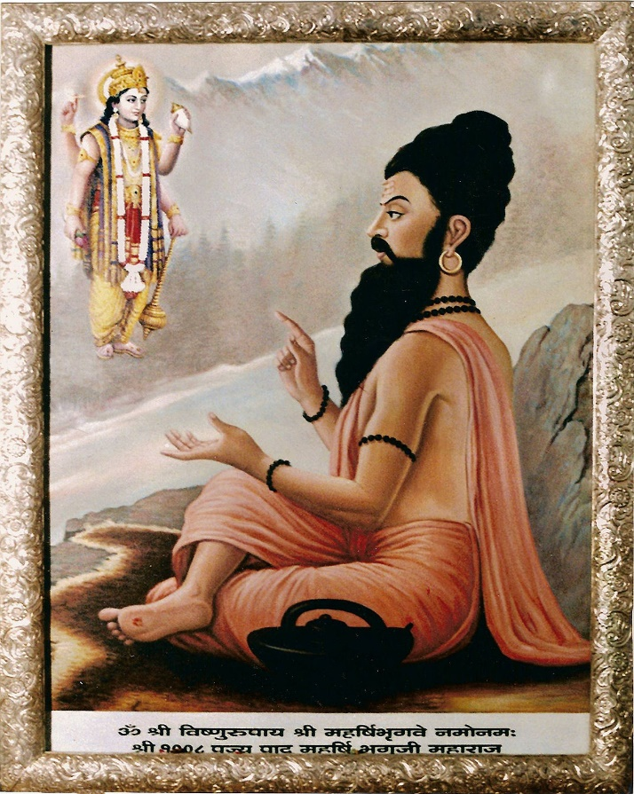Bhrigu was enraged by this. First, Bhrigu revived his wife by giving her air. Bhrigu then went to Vishnu and cursed, “You will be born multiple times on Earth with a human form!” In response, Vishnu threw his Sudarshan Chakra at Bhrigu. Bhrigu fled in panic and at last, surrendered himself in front of Lord Vishnu. Vishnu then withdrew his Sudarshan Chakra. As a result of Bhrigu’s curse, Vishnu was born on Earth as Krishna, Rama, Parshuram, and others.

**Kicking Vishnu**

Long ago, all the Maharishis gathered to perform a yagna on the bank of the Saraswati river. A dispute arose as to who was the most superior from the Trimurti. Some voted for Vishnu, while others supported Brahma or Shiva. To solve the problem, they elected Bhrigu to find out the truth.

Bhrigu first went to [Satyaloka](https://glorioushinduism.com/2016/10/08/satyaloka/), Brahma’s abode. Bhrigu sat down on a stool in the throne room. Brahma was provoked by this disrespectful act of Bhrigu. Realizing this, Bhrigu left the assembly without a word.

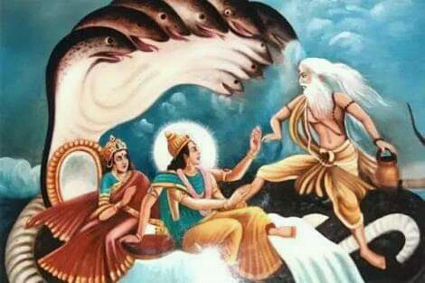

Bhrigu then arrived at Kailash and Shiva approached Bhrigu to embrace him. But Bhrigu stepped back and said, “Do not touch me!” Shiva was enraged and raised his trident at Bhrigu. But [Parvati](https://glorioushinduism.com/2017/04/29/parvati/) was able to stop Shiva in time.

Lastly, Bhrigu went to Vaikuntha and saw Vishnu in a deep slumber. “How can the preserver of the world be irresponsibly sleeping like this?” Bhrigu wondered. Bhrigu kicked Vishnu on his breast. Vishnu woke up because of the kick and saw Bhrigu standing in front of him. Frightened, Bhrigu begged pardon of Vishnu. But instead, Vishnu welcomed Bhrigu and apologized for not noticing his arrival. “Your footprints will forever stay on my chest,” Vishnu said. This footprint still remains on Vishnu’s chest and is known as “Srivatsa”. Impressed by Vishnu’s behavior, Bhrigu and the other Maharishis declared that Vishnu is the greatest of the Trimurtis.

**Writing the Bhrigu Samhita**

After testing the trinity, Bhrigu decided to write a book on astrology which he called Bhrigu Samhita. He collected birth charts and wrote full-life predictions. The Bhrigu Samhita was the first book on predictive astrology. Bhrigu also contributed to Manusmriti.

**Origin of Bhrigu Tirtha**

Bhrigu once performed penance to please Lord Shiva. Because of the severity of the penance, Bhrigu’s hair became discolored and his skin was covered by earth heaped up by termites. But Lord Shiva was not pleased, so Parvati had to tell Shiva to bless Bhrigu. Shiva then agreed to appear before Bhrigu.

Shiva sent his bull to the place where Bhrigu was meditating. The bull destroyed the earthen covering around Bhrigu. Bhrigu became angry and chased the bull. But suddenly the bull started rising up to heaven. Shiva appeared there and asked Bhrigu what he wanted. Bhrigu prayed that the place in which he was performing penance should become a holy spot. From that day, the place became known as “Bhrigu Tirtha”. All sin is removed by a mere sight of this place and bathing here can take you to Swarga. Even hearing about his place clears your path to Shivaloka.

**Places associated with Bhrigu**

Bhrigu's Ashram 'Deepotsaka' was located at the base of Dhosi Hill in present-day village Dhosi on the border of Narnaul district in Haryana and Jhunjunu district of Rajasthan, from where he migrated to Bharuch. His son Chyavana, known for Chyavanprash also had his Ashram at Dhosi Hill. Bhrigu is also worshipped at Bharuch, Swamimalai, Tirumala, Ballia, Nanguneri, Thiruneermalai, Mannargudi. An Ashram for Bhrigu is in Maruderi, Kanchipuram district in Tamil Nadu. Khedbrahma in Gujarat is associated with Brahma and Bhrigu 's legend of testing Trinity. Lastly, Bhrigu migrated to Bhuinj Satara, Maharashtra where he took Samadhi. His ashram and his daughter's Laxmi's temple also situated there. His sons chyavan's ashram and samadhi are also situated on chyavaneshwar hill near Bhuinj. Sage Bhrigu is the founder of the bloodline and Bhargava Gotra. The Sampangirama family is one of the many families that contains the decedents of Sage Bhrigu. The Sampangirama family goes by many last names, the most notable being Sampangirama, Nagar, and Rao. The Sampangirama family follows the pravara (bloodline): Bhargava, Chyavana, Apnavana, Aurva, Jamadagni, Parashurama.